Game Design Document

Fill up the following document

1. Write the title of your project.

Futpenales

1. What is the goal of the game?

Score penalties

1. Write a brief story of your game.

Your soccer team and other haven´t scored any goal yet. So the extra

time passes and the penalties come.

1. Which are the playing characters of this game?

* Playing characters are the ones who respond to the user based on the input from the user.
* Cars, monkeys, dinos, wizards, etc., are the playing characters in the game.

|  |  |  |
| --- | --- | --- |
| Number | Character Name | What can this character do? |
| 1 | Player | Score or fail |

1. Which are the Non-Playing Characters of this game?

* Non-Playing characters are the ones that don't have an action or behavior when the user interacts with the game.
* Hurdles, stones, bananas, coins, etc., are non-playing characters in the game.

|  |  |  |
| --- | --- | --- |
| Number | Character Name | What can this character do? |
| 1 | Ball | Define the game |
| 2 | Goalkeeper | Save the ball from entering the goal |

Draw your imagination of this game. What does this game look like?

* Draw the game either on your computer or on paper.
* Add images of the game scenes to show each of the playing and non-playing characters at least once.

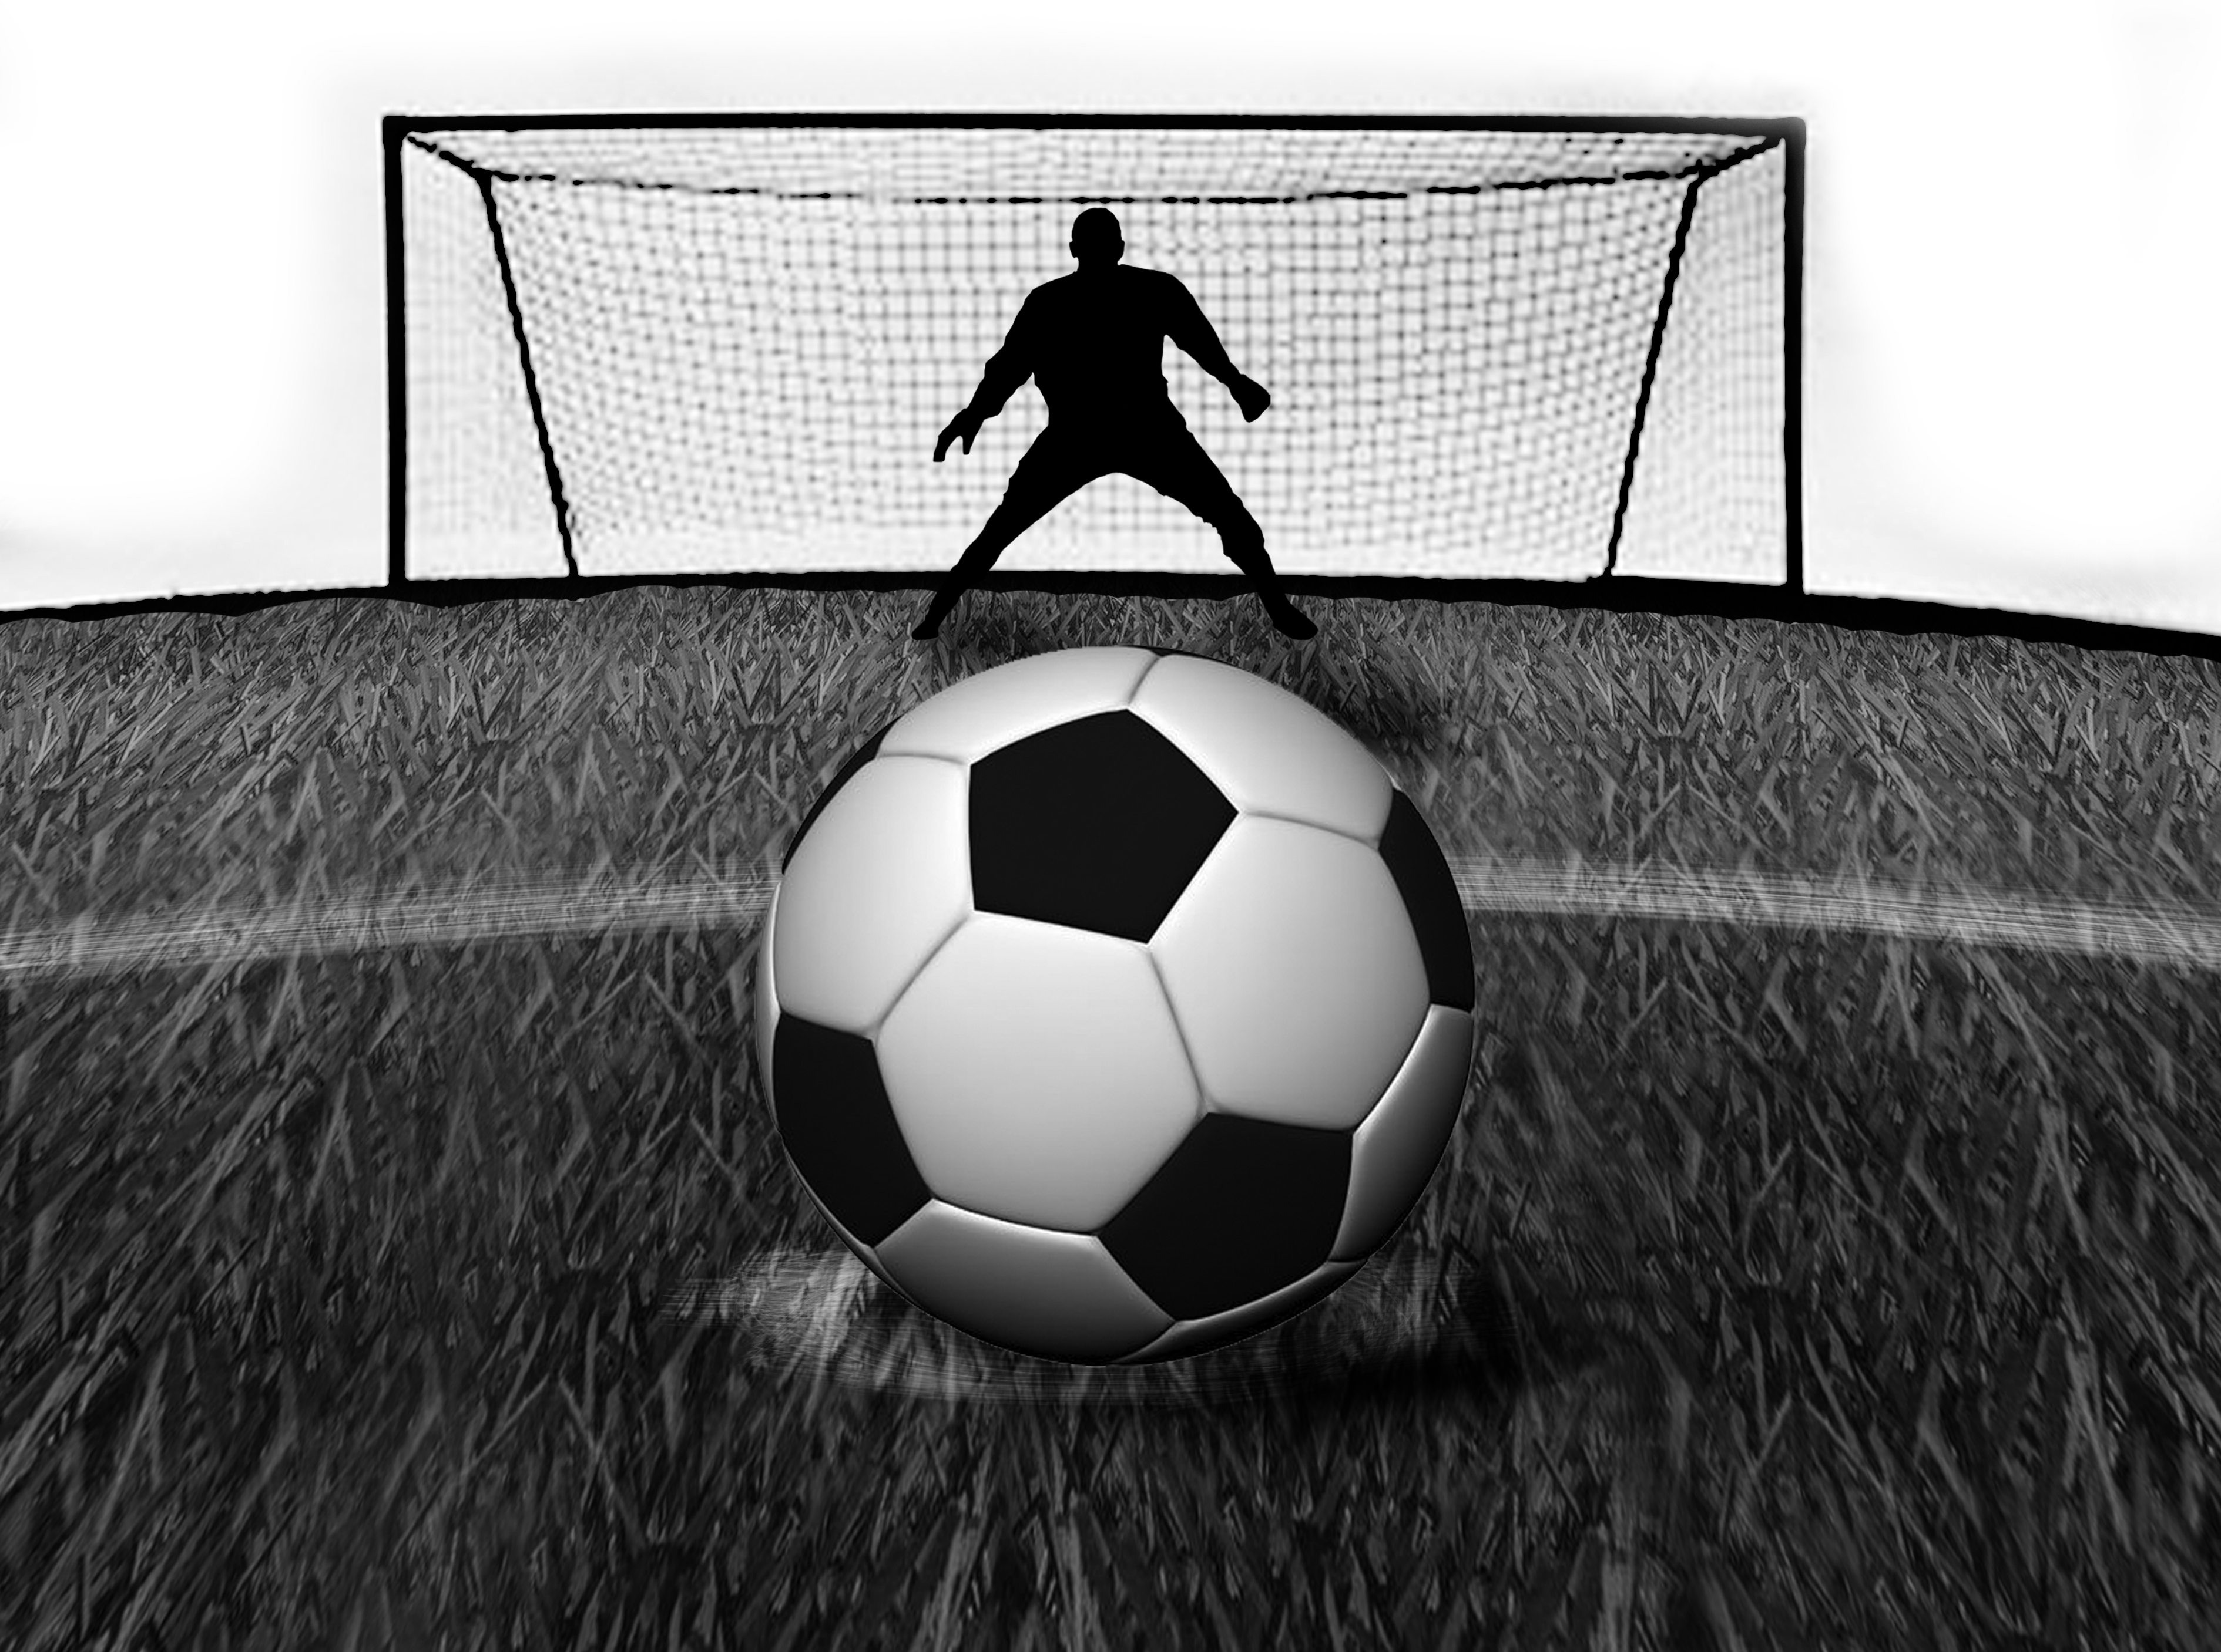

How do you plan to make your game engaging?

Different goalkeepers, effects on the ball, nerves in the player.